Exp No: 6
Arduino to 16x2 LCD Display using Proteus
AIM: To write an Embedded C program to interface Arduino Uno and 16 x 2 LCD display using Arduino Uno and Proteus

SOFTWARE REQUIRED :
- Proteus 8 software
- Arduino IDE software

PROGRAM :
#include <LiquidCrystal.h>
// Initialize the library with the numbers of the interface pins
const int rs = 12, en = 11, d4 = 5, d5 = 4, d6 = 3, d7 = 2;
LiquidCrystal lcd(rs, en, d4, d5, d6, d7);
void setup() {
// Set up the LCD's number of columns and rows
lcd.begin(16, 2);
// Print a message to the LCD.
lcd.print("hello, world!");
}
void loop() {
// Set the cursor to column 0, line 1 (the second line)
lcd.setCursor(0, 1);
// Print the number of seconds since the board was reset
lcd.print(millis() / 1000);
}

OUTPUT :
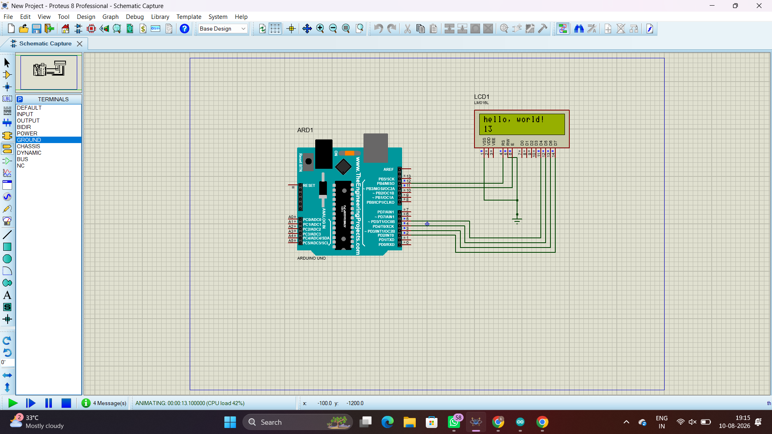
RESULT :
Thus the program has been successfully verified and executed

